1. Cottage-Style Fruit
Top 1/2 cup cottage cheese with 1/2 cup of your favorite fruit. Not sure what fruit to pick? Try some superfoods, mixed berries, .

2. Beef or Turkey Jerky
Be careful to avoid sodium- and sugar-filled brands, but low-sodium, natural, or lightly-flavored options are a great source of protein. A one-ounce serving (the size of most single-serve packs) contains about 9 grams of protein! This chewy snack is also super portable and keeps fresh for months when packed properly.

3. Mixed Nuts or Trail Mix
Mixed nuts provide an easy way to get a delicious dose of protein in a convenient, shelf-stable package. Try a mixed bunch for variety and a combo with dried fruit for some added sweetness. The best bang for your protein buck? Almonds and pistachios. They're higher in protein than their nutty peers.

4. Pumpkin Seeds
Those orange gourds aren’t just for Halloween. Pumpkin insides, scooped out to make room for spooky faces, can actually make a healthy little snack once they’re washed, dried, and nicely roasted. Just 1/2 cup of pumpkin seeds has about 14 grams of protein, making it the perfect pre-workout snack!

5. Hard-Boiled Eggs
Inexpensive and loaded with nutrients, eggs are one of the best ways to get a healthy dose of protein. Try hard boiling and pre-peeling a dozen at the start of the week and throw one in a small Tupperware container each day for an easy on-the-go snack. (Feeling extra famished? Slice the egg and place it on a piece of whole-wheat bread.)
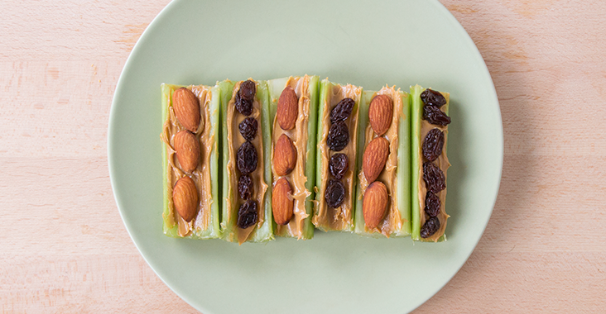

6. Nut Butter Boat
Any vehicle for nut butter is perfection in our book. Try loading a few celery sticks with 1 tablespoon of any nut butter (almond, cashew, walnut) topped with a few whole almonds or raisins. If you’re not a fan of celery, try scooping out the middle of an apple and filling it with your nut butter of choice.

7. Deli Rollup
Top 2 slices of deli meat (turkey, chicken, or roast beef work great) with 1 slice of cheese and a shake of pepper. Add a slice of tomato or some lettuce for extra veggie points!

8. Shake It Up
When it comes to protein shakes, the combinations are endless, and one scoop can go a long way! The "Protein Creamsicle:" 1 scoop vanilla whey protein powder, 1 cup orange juice, and 1 cup ice blended until smooth. And also the "Star-buffs Shake:" 1 cup iced coffee (with ice) and 1 scoop chocolate whey protein, blended.

9. Chunky Shake
It’s time to get funky, monkey! Blend ½ avocado, 1 tablespoon of peanut butter, and 1 cup of chocolate milk with 1 cup of ice for a protein-packed pick-me-up.

10. Tofu Sticks
This soybean-based protein bomb isn’t just for stir-fry. When sliced into sticks and baked, firm (and smoked) tofu can make a great snack food—especially if it’s served with a side of homemade tomato or teriyaki dipping sauce.

11. Edamame Poppers
The only thing more fun than how much protein you can get from a serving of edamame (one cup offers about 17 grams of protein!) is getting to eat these little beans out of their bright green pods. Buy them fresh and steam for about 6 minutes, or use the pre-cooked frozen variety and briefly microwave to defrost (about 2 minutes) before chowing down.

12. Hummus Dippers
How’s this for an unconventional use of a travel coffee mug? Put 2 tablespoons of your favorite hummus in the bottom of the container, stick a handful of vegetable sticks (carrots, celery, and snow peas are a great mix) vertically in the hummus, screw on the top, and throw in a purse or gym bag for an easy, on-the-go, super-healthy

